**W203 Section 6 K Iwasaki HW 3**

1. **Gas Station Analytics:**

(a) P(R, F) = P(R) P(F|R) = 0.4 * 0.3 = 0.12. **12%**

(b) P(F) = P(R, F) + P(M, F) + P(P, F) = 0.4 * 0.3 + 0.35 * 0.6 + 0.25 * 0.5 = 0.455. **45.5%**

(c) P(R|F) = P(R, F) / P(F) = 0.12 / 0.455 = 0.2637363. **26.4%**

1. **The Toy Bin:**

(a)

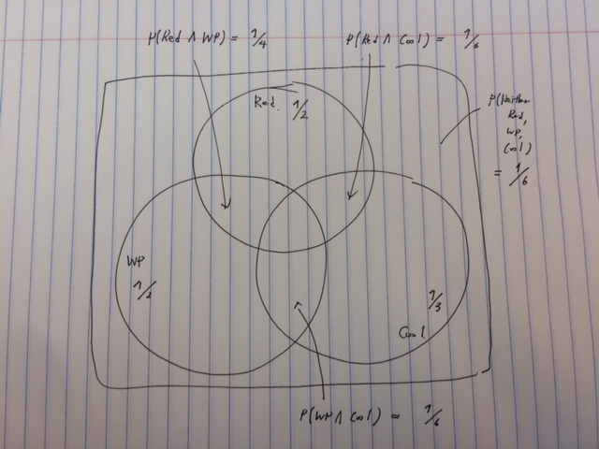

(b) P(Red) + P(WP) + P(Cool) – P(Red, WP) – P(Red, Cool) – P(Cool, WP) + P(Red, WP, Cool) + P(Neither Red, WP, Cool) = 1

P(Red, WP, Cool)

= 1 – P(Red) – P(WP) – P(Cool) + P(Red, Cool) + P(Cool, WP) + P(Red, WP) – P(Neither Red, WP, Cool)

= 1 - 1/2 - 1/2 - 1/3 + 1/4 + 1/6 + 1/6 - 1/6

= 0.08333333.  **8.3%**

(c) P(! Cool | Red) = P(! Cool, Red) / P(Red) = (1/2 – 1/6) / ½ = 0.666.. 67%

(d) P(Cool | (Red U WP)) = P(Cool, (Red U WP)) / P(Red U WP)

= (P(Cool, Red) + P(Cool, WP) – P(Red, Cool, WP)) / P(Red U WP)

= 0.3333…

**33%**

1. **On the Overlap of two events**
2. P(A, B) becomes largest when event A happens, event B always happens. This is when P(B|A) = 1. Thus, P(A, B) = P(A)P(B | A) = 1/2 * 1 = **1/2**

Minimum case is when 1 = P(A) + P(B) – P(A, B) Thus, P(A, B) =1/2 + 2/3 – 1 = **1/6**

1. P(A|B) = P(A)P(B|A) / P(B) When P(B|A) is maximum, P(A|B) is also maximum.

P(A|B) = 1/2 * 1 / (2/3) = **3/4.**

P(A|B) = P(A, B) / P(B) Thus when P(A, B) is minimum, P(A|B) is minimum. Minimum value for P(A|B) has calculated in (a) as 1/6.

P(A|B) = (1/6) / (2/3) =**1/4**.

1. **Can’t Please Everyone!**

Define event C as students complete w203 and event L as students like stats.

According to Bays rule P(C|L) = P(C)P(L|C) / P(L)

P(C) = 1/100

P(L|C) =3/4

P(L) = P(C)P(L|C) + P(!C)P(L|!C) = 0.255

Plug in all these numbers to P(C|L). P(C|L) = 0.02941176. **2.9%**